Hikashop->Configuration->Display:
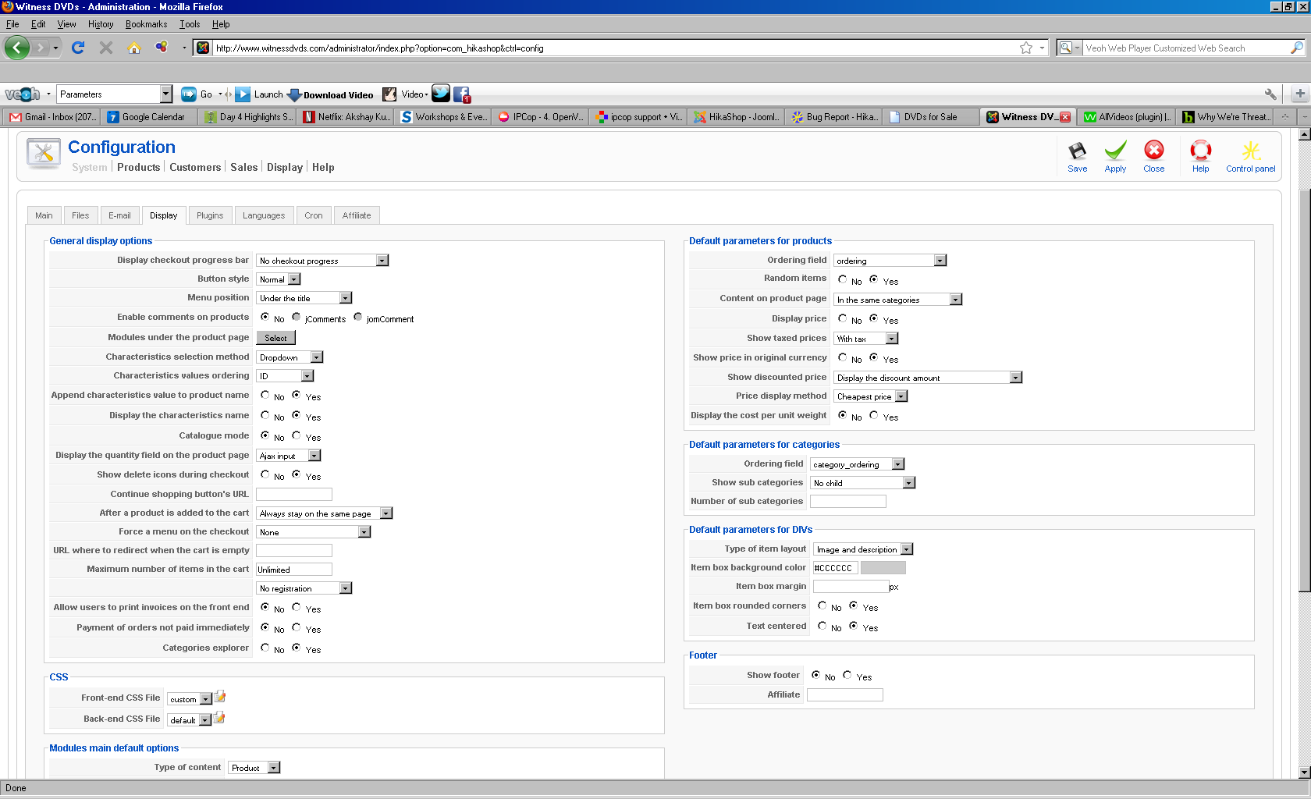

Menu Item for “Products”, the relevant page:
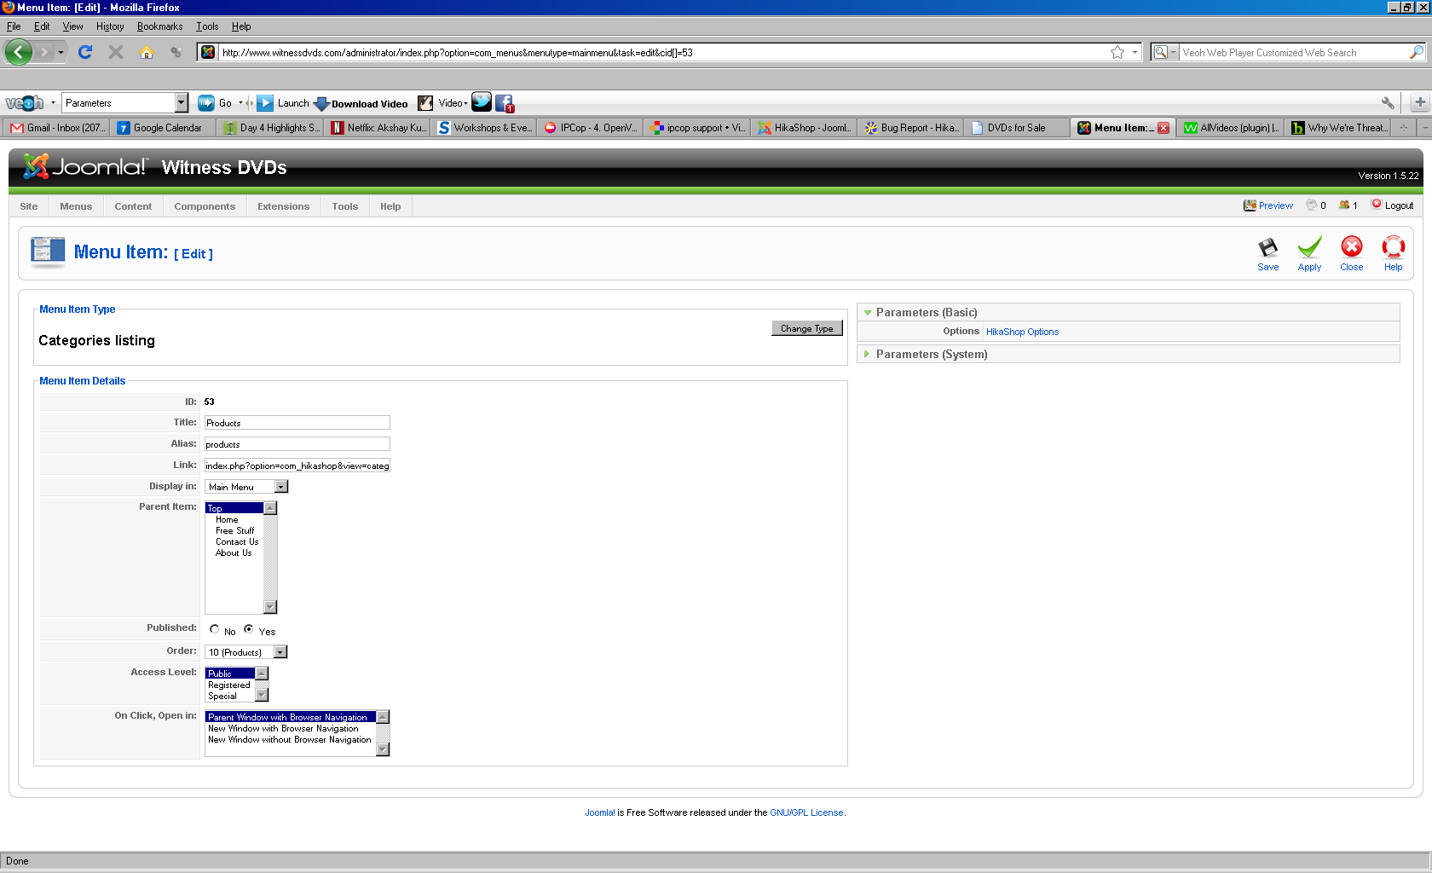

And following the link to “Hikashop options”:
