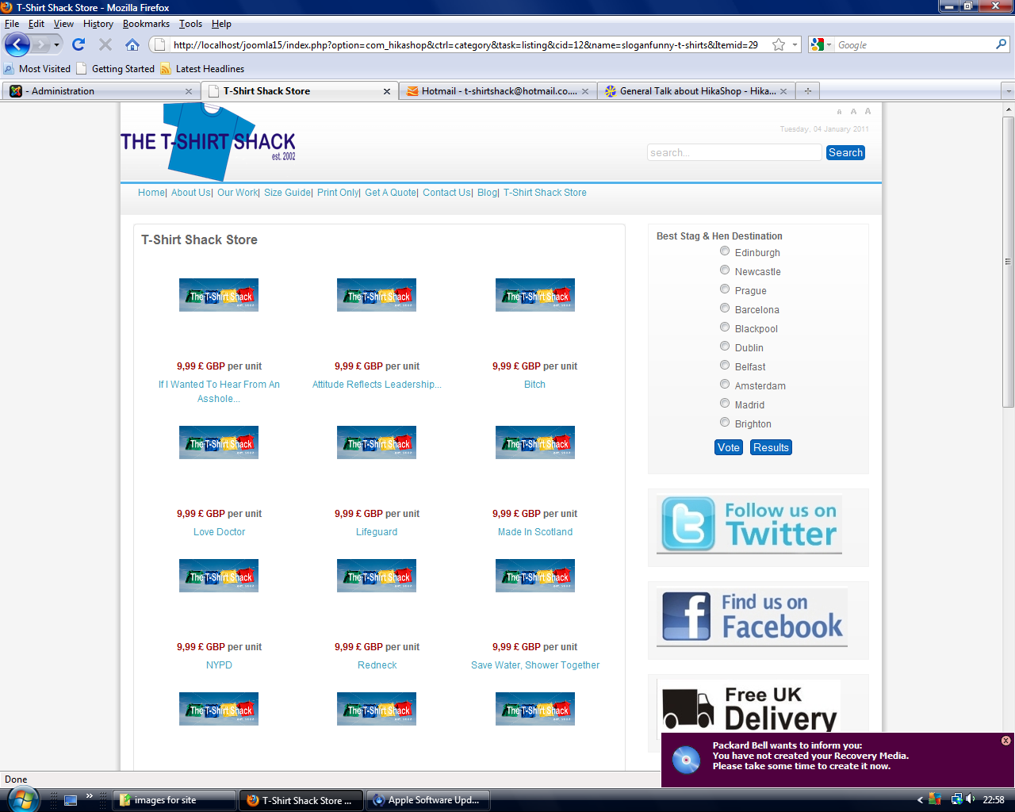
Continued page two, this shows the duplicate listings on the same page (no product thumbnails as you can see)
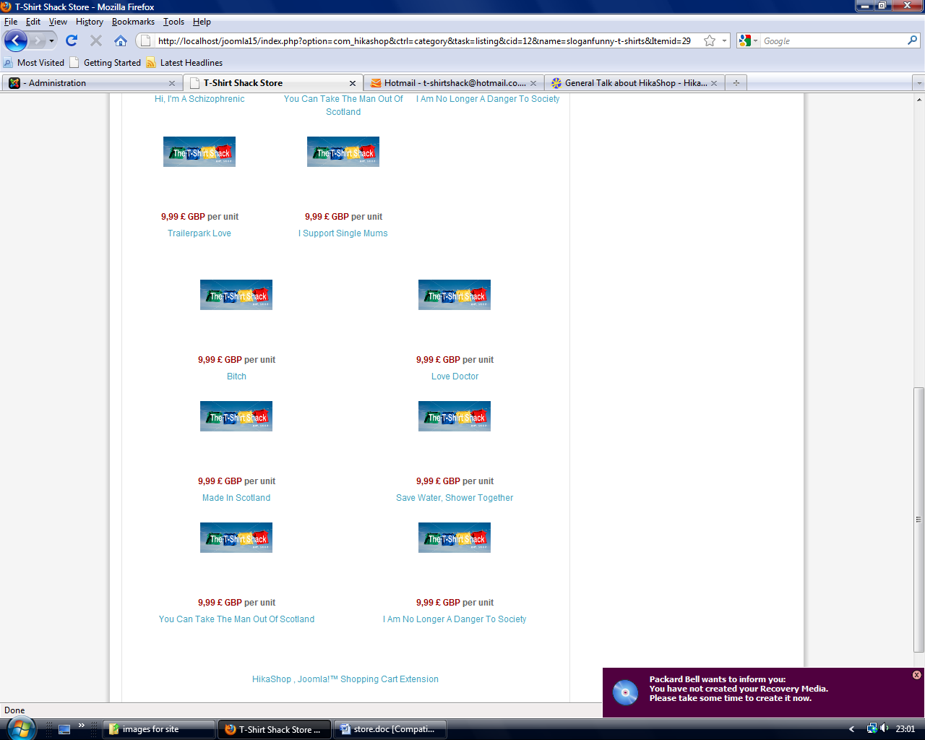
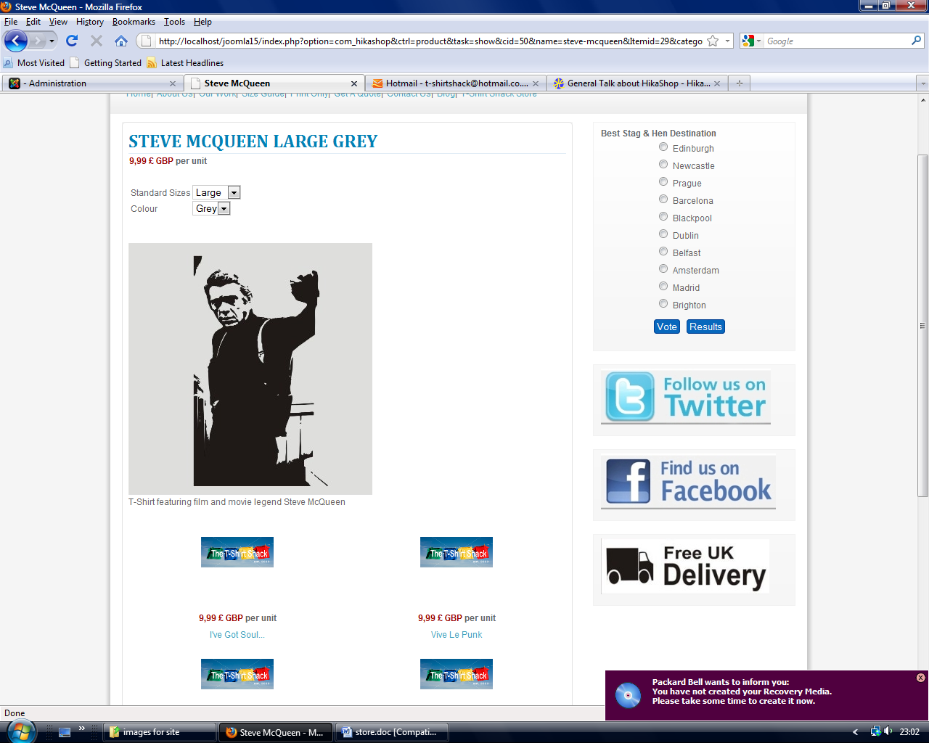
Product page (note the title as described) and the random products below

