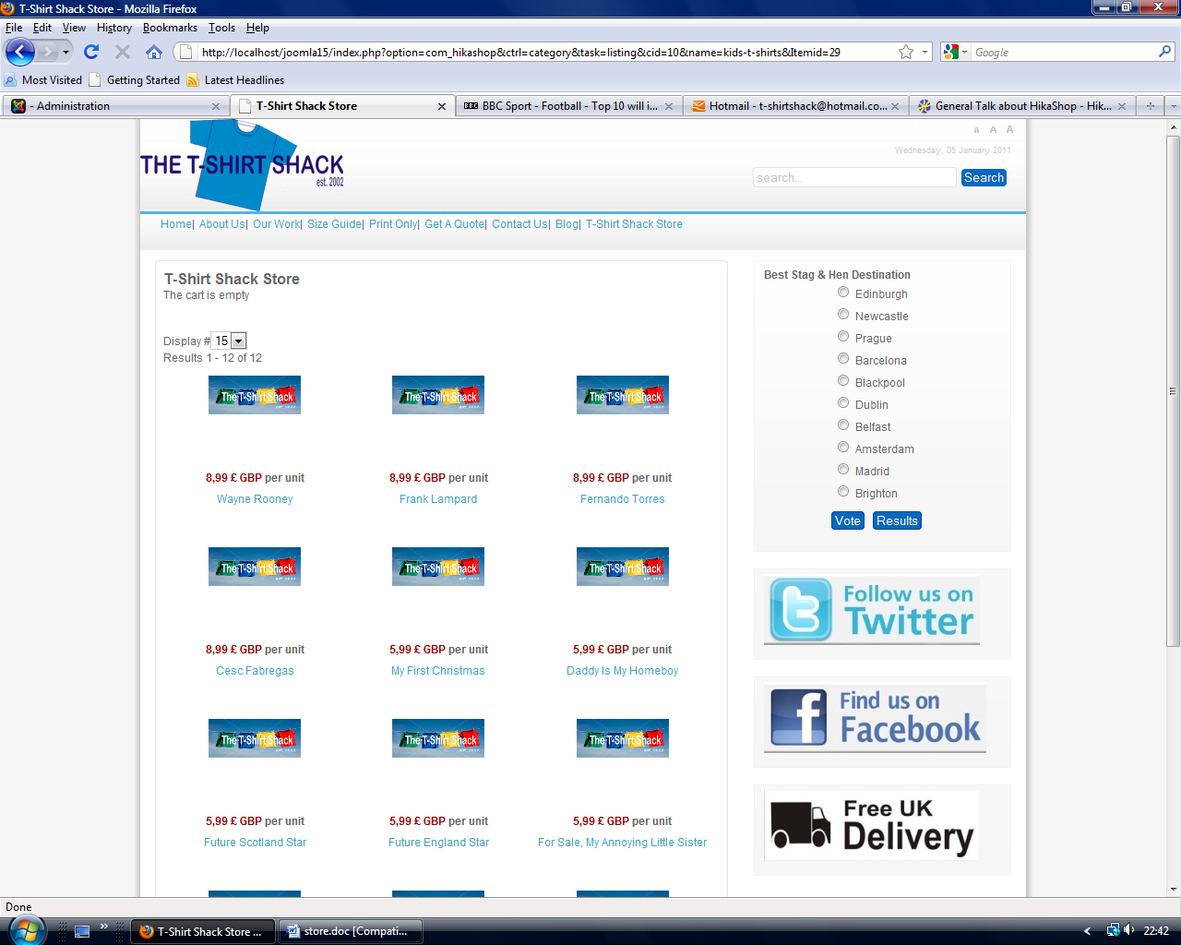
Listings in category showing default image in all thumbnails. Note in particular “Wayne Rooney as example given below
