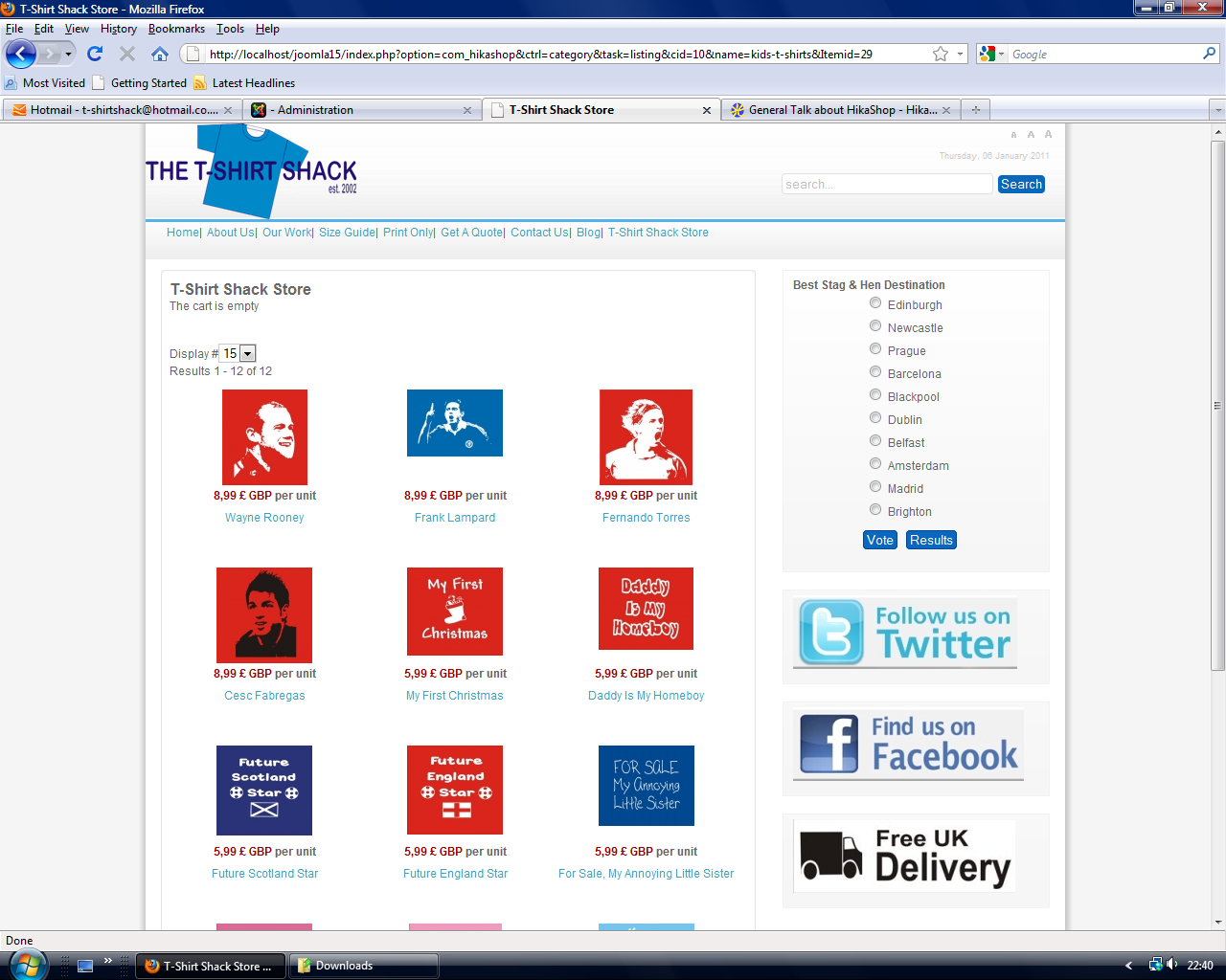
Category with text showing “The Cart Is Empty”

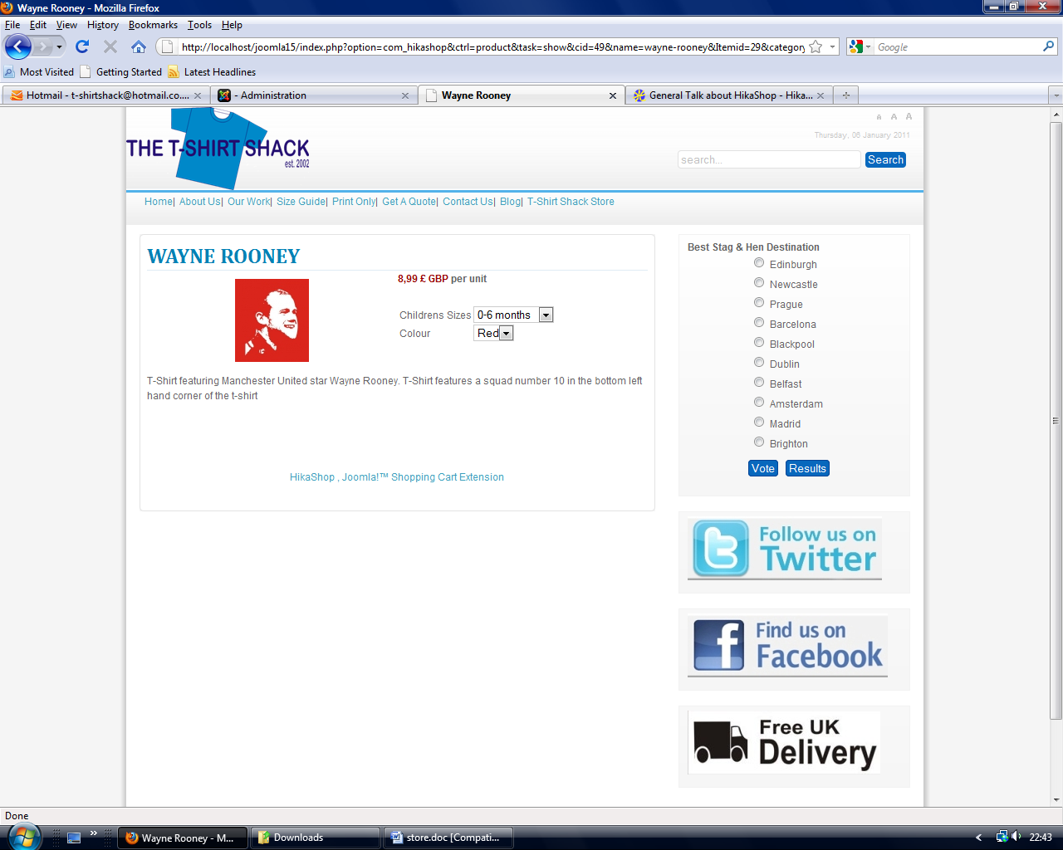
Product Listing with no Add To Cart option

