Joomla 3 + Hikashop Essentials

HikaShop Essential 2.1.3, Joomla!™ E-Commerce Extension

Error clicking the Select button for Associated Category.
Same happens for Associated modules.

Cannot assign another Category or Module.

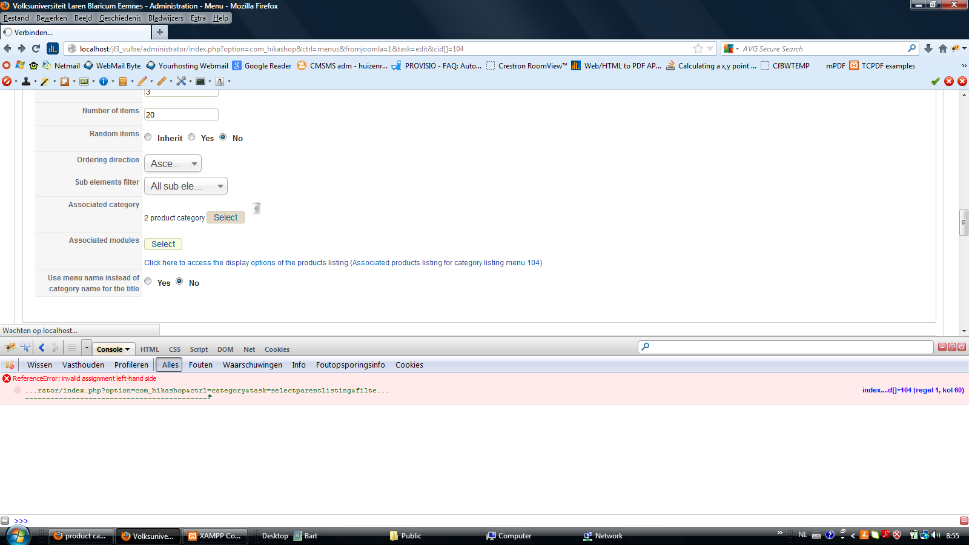
Clicking on Select button no pop-up occurs to select a category from but results in another screen (see below). I expect some kind of light box pop-up to choose the category from.
Firebug gives a reference / invalid assignment error. See the console part of the screen.

Something not good in the “blue” statement in the screenprint below.

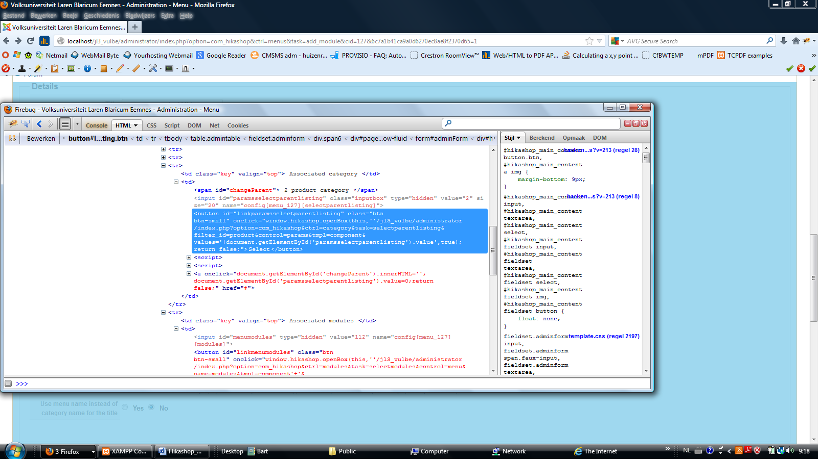
The screen below occurs instead of the expected pop-up on clicking the Select button.

Note: I am using the Hathor template for administrator backend. Same occurs with the Isis template.

