Shoppingcart without any coupons:



“Normal coupon”:

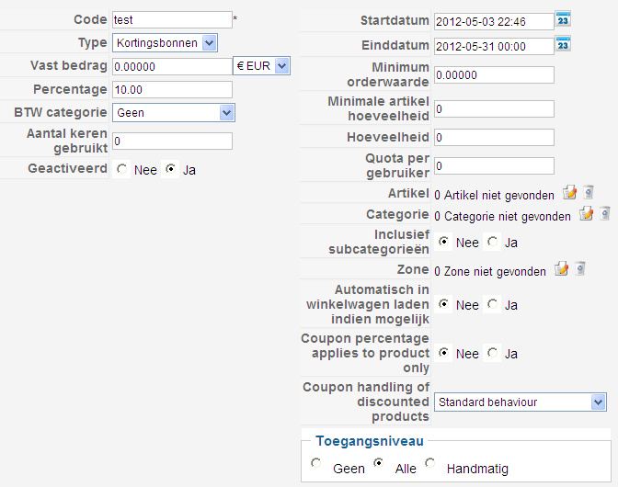
Shoppingcart with the ‘normal’ coupon:


You see the discount is now calculated to € 1,20.

“More complex coupon”:

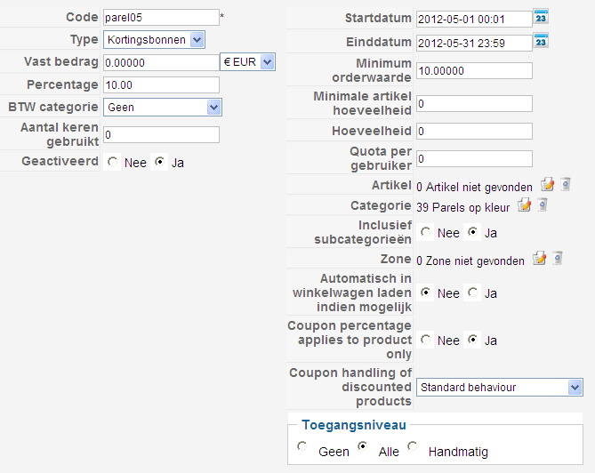
Shoppingcart with the ‘more complex’ coupon:


You see that now the discount is only € 1,00.

