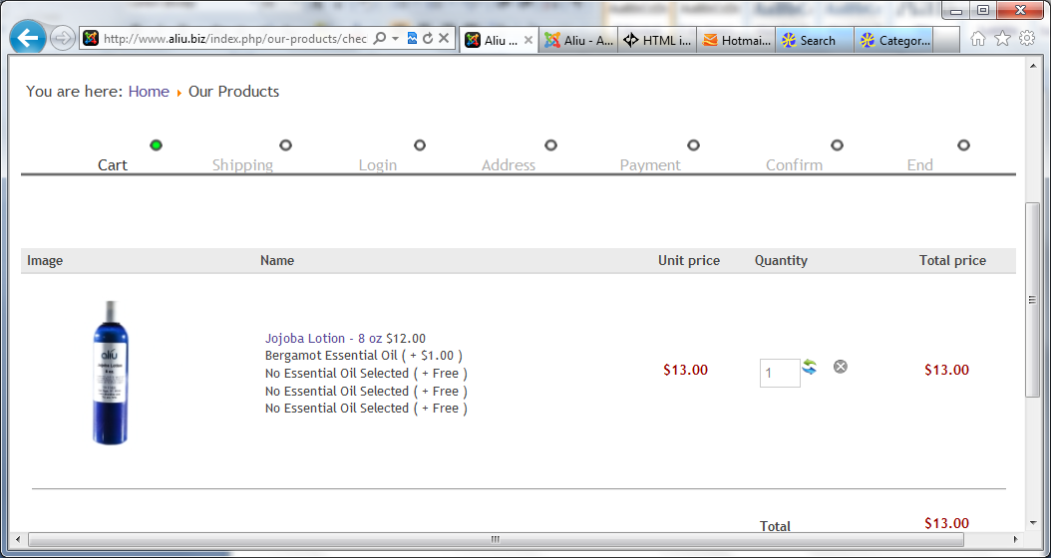

|  |
| --- |
| We are pleased to confirm the creation of your order No. J8 ( http://www.aliu.biz/index.php?option=com_hikashop&ctrl=order&task=show&cid[]=8&Itemid=118 ) at http://www.aliu.biz/ on the 12 April 2012 at 09:20 |
|  |
| SUMMARY OF YOUR ORDER   |  |  |  |  | | --- | --- | --- | --- | | **Name** | **Unit price** | **Qty** | **Total** | | Virgin Coconut Sugar Scrub - 6 oz | $12.97 | 1 | $12.97 | | Jojoba Lotion - 8 oz | $12.97 | 1 | $12.97 | | Lime Essential Oil | $1.08 | 1 | $1.08 | | Orange Essential Oil | $1.08 | 1 | $1.08 | | Natural Vanilla Essential Oil | $1.00 | 1 | $1.00 | | No Essential Oil Selected | $0.00 | 1 | $0.00 | | No Essential Oil Selected | $0.00 | 1 | $0.00 | | No Essential Oil Selected | $0.00 | 1 | $0.00 | | No Essential Oil Selected | $0.00 | 1 | $0.00 | | No Essential Oil Selected | $0.00 | 1 | $0.00 | | Shipping method : $8.68 | | | | | TOTAL without VAT : $35.68 | | | | | **TOTAL with VAT : $37.78** | | | | |