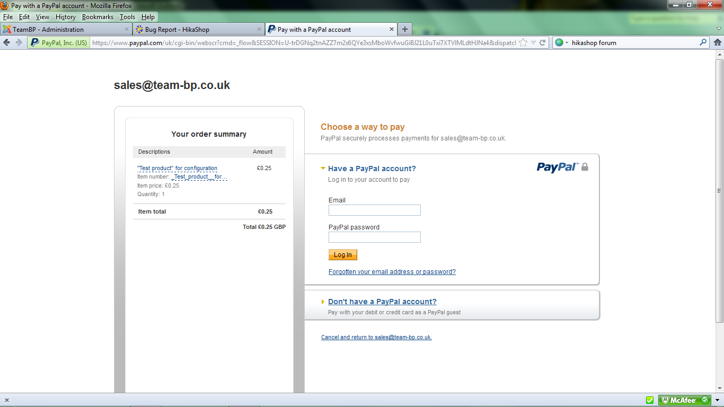

This needs several clicks before working, each time having to reload the entire page