363M
JERZEES
100% Cotton T-Shirt

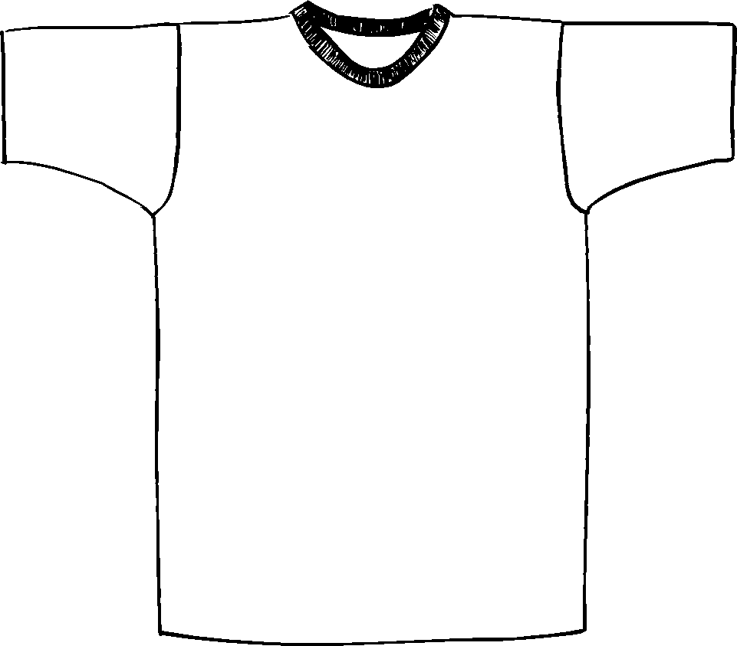

Descriptions
*100% cotton, 5.6 ounce
*20 Singles
*Taped shoulder to shoulder
*Coverseamed at front neck
*Double needle sleeve and bottom hem
*1” Ribbed collar
*Pre-Shrunk
*Embroidery or screenprinting okay

Finished Garment Measurements

Size | S | M | L | XL | 2XL | 3XL
Width | 19 | 21 | 23 | 25 | 27 | 29
Length | 28 | 29 | 30 | 31 | 32 | 33
Sleeve Length | 7 5/8 | 8 1/8 | 8 5/8 | 9 1/8 | 9/18 | 9 1/8

