Version identification:
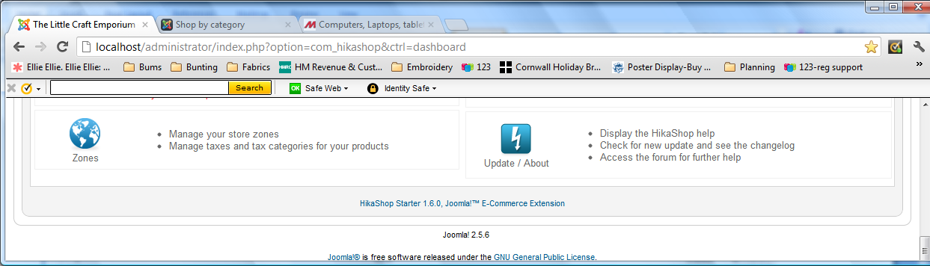
Shipping “plugin” identification:
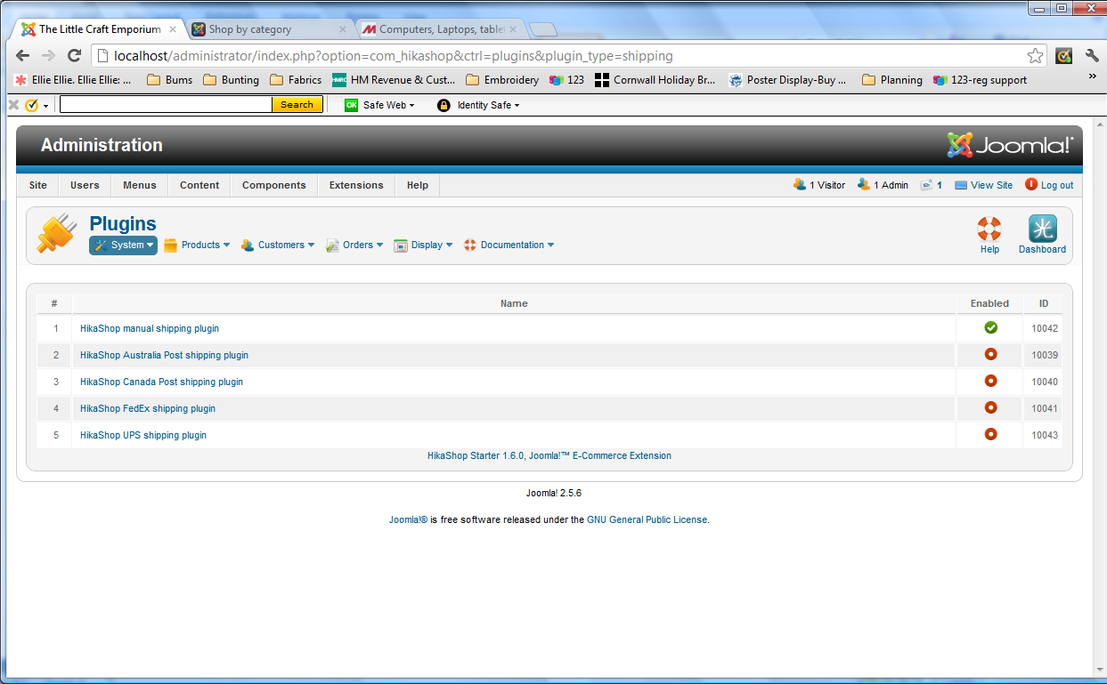

Manual shipping has been configured based on weight alone:
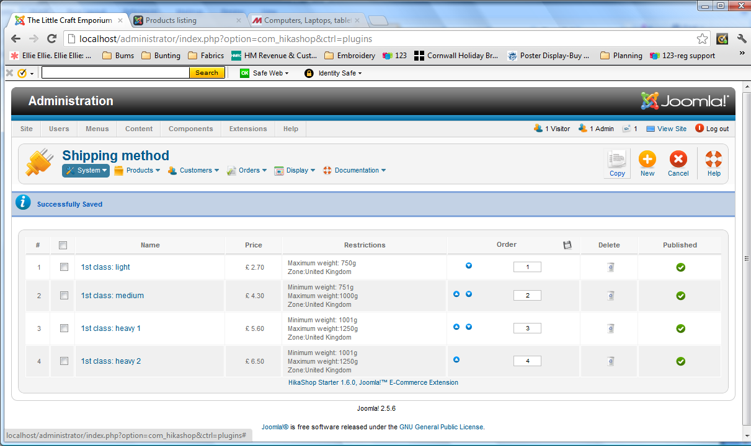

Add one product, weight 500 and then checkout and the shipping choice/price is correct – only one option matches:
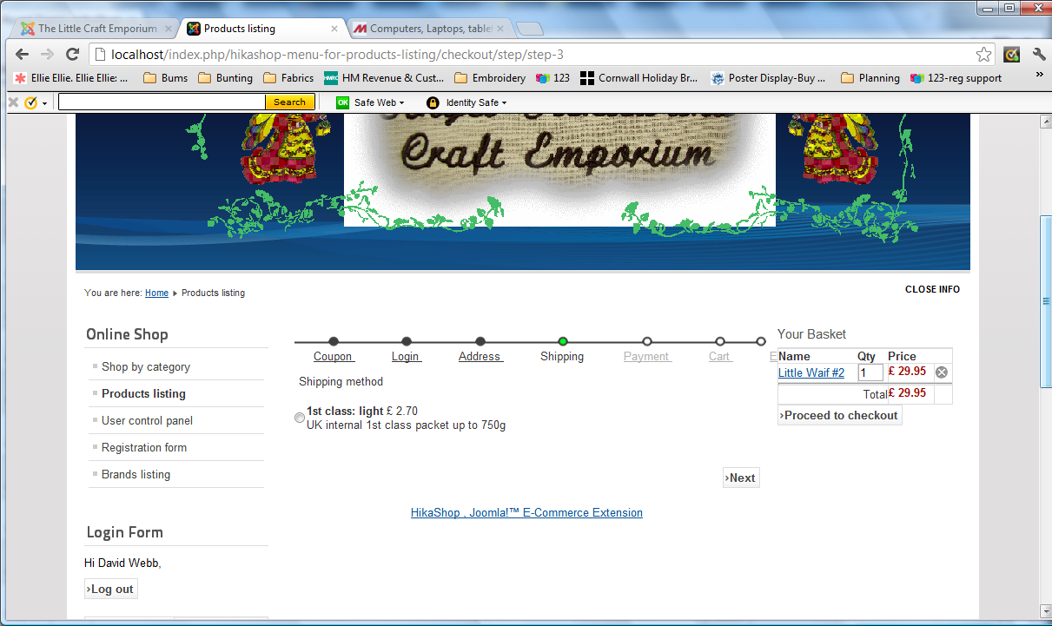

However, add a product weight 850 and checkout, and two shipping options are displayed. One of these is for weight 0 to 750 so should NOT be available:
