Alignement - Bouton radio

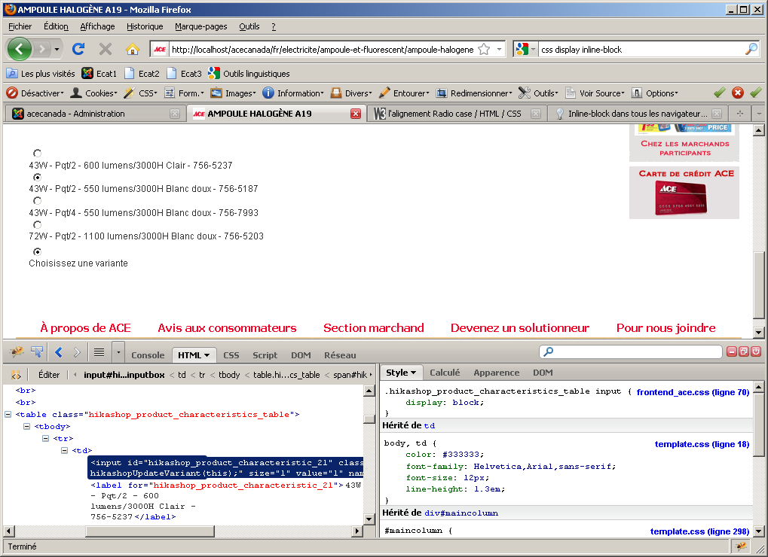
/* footer display */
div.hikashop_footer{
padding-top : 20px;
clear:both;
padding-bottom : 20px;
}

/* category display */
div.hikashop_category_image{
clear:both;
}
img.hikashop_category_image {
margin: 4px;
}
table.hikashop_subcategories_table tr td{
text-align:center;
}
#hikashop_subcategories div {
text-align:center;
}
.hikashop_category_list{
margin:0px;
}
.hikashop_category_left_part{
text-align:center;
}
.hikashop_category_right_part{
padding-left:1px;
}
.hikashop_subcontainer{
padding-top:10px;
padding-bottom:10px;
}
.hikashop_ace{
padding-top:10px;
padding-bottom:10px;
background-image: url('../images/fond_produit.jpg');
height:190px;
width: 141px;
}
.hikashop_product_image{
padding-top:5px;
}
/* different parts of the show of a product */
.hikashop_product_top_part{
width:100%;
padding:20px 20px 20px 0px;
}
.hikashop_product_left_part{
text-align:center;
float:left;
width:25%;
padding:10px;
margin-top:30px;
background-image: url('../images/fond_produit_main.jpg');
background-repeat: no-repeat;
height:170px;
}
.hikashop_product_right_part{
float:left;
padding-left:1px;
width:65%;
}
.hikashop_product_bottom_part{
clear:both;
width:100%;
padding-top:30px;
}

.hikashop_product_characteristics_table input{
display: block;
}
.hikashop_product_characteristic_chooser{
text-align:center;
}
.hikashop_product_quantity_field{
width:25px;
}
a.hikashop_product_quantity_field_change:hover{
text-decoration: none;
}
.hikashop_no_border tr, .hikashop_no_border td,
#hikashop_address_listing tr, #hikashop_address_listing td, #hikashop_address_form_span_iframe tr,
#hikashop_address_form_span_iframe td, #hikashop_product_quantity_main tr,#hikashop_product_quantity_main td,
#hikashop_checkout_page tr,#hikashop_checkout_page td, #hikashop_affiliate_main tr, #hikashop_affiliate_main td{
border:0px solid #DDDDDD;
}
#hikashop_order_listing fieldset,#hikashop_address_listing fieldset, #hikashop_affiliate_main fieldset{
border:1px solid #CCCCCC;
background-color:#FFFFFF;
}

div#hikashop_product_left_part div{
text-align:left;
}
div#hikashop_product_left_part img.hikashop_child_image{
margin : 2px;
height:25px;
}
div#hikashop_main_image_div{
margin-left: 18px;
}
div#ace_separateur_produit{
margin-top: 30px;
}
.hikashop_product_code_main{
display:none;
}
.hikashop_product_weight_main{
display:none;
}
span.hikashop_product_name{
display:block;
margin-bottom:5px;
padding-left: 3px;
padding-right: 3px;
}
span.hikashop_product_name_main{
color:#0000FF;
}

/* prices display */
span.hikashop_product_price_before_discount{
text-decoration:line-through;
white-space:nowrap;
}
span.hikashop_product_price{
color:#990000;
white-space:nowrap;
}
span.hikashop_product_discount{
white-space:nowrap;
}
span.hikashop_product_price_full{
font-weight:bold;
display:block;
margin-bottom:5px;
}
span.hikashop_checkout_cart_coupon{
font-weight:bold;
}
span.hikashop_checkout_cart_shipping{
font-weight:bold;
}
span.hikashop_checkout_cart_taxes{
font-weight:bold;
}
span.hikashop_checkout_cart_final_total{
font-weight:bold;
color:#990000;
}

/* pagination */
.pagenav{
cursor:pointer;
}
.list-footer li{
list-style-type:none;
display: inline;
}

/* product name in the cart layout of the checkout process */
#hikashop_cart .hikashop_cart_product_name a{
font-weight:bold;
}

/* titles for cart display */
.hikashop_cart_title{
font-weight: bold;
}

/* next button of the checkout process */
#hikashop_checkout_next_button{
float:right;
}
#hikashop_checkout_shopping_button{
float:left;
}
.hikashop_submodules{
padding-top:30px;
}

/* cart buttons */
a.hikashop_cart_button, a.hikashop_cart_button:hover{
background-image:url(../images/button.jpg);
border:1px solid #356AA0;
color:#000000;
font-family:Verdana,Arial,Helvetica,sans-serif;
font-size:11px;
padding:5px 8px;
text-decoration:none;
cursor:pointer;
float:left;
white-space:nowrap;
}
a.hikashop_cart_button:hover{
outline: 2px solid #92C1FF;
}
#hikashop_order_listing a.hikashop_cart_button, #hikashop_order_listing a.hikashop_cart_button:hover{
float:none;
}

.hikashop_products a.hikashop_cart_button,.hikashop_products a.hikashop_cart_button:hover, #hikashop_checkout_coupon a.hikashop_cart_button,#hikashop_checkout_coupon a.hikashop_cart_button:hover{
float:none;
width:100px;
}

#hikashop_button_1 div.hikashop_container,#hikashop_button_2 div.hikashop_container,#hikashop_button_3 div.hikashop_container {
cursor:pointer;
}
#hikashop_button_1 div.hikashop_subcontainer, #hikashop_button_2 div.hikashop_subcontainer, #hikashop_button_3 div.hikashop_subcontainer,#hikashop_order_listing div.hikashop_subcontainer {
text-align:center;
}

/* checkout progress bar styles */
.hikashop_cart_bar{
background: url(../images/line.png) repeat-x scroll 100% 50% transparent;
padding-bottom:0;
padding-top:33px;
}
#hikashop_checkout_page div.hikashop_cart_bar{
text-align:center;
}
#hikashop_checkout_page .hikashop_cart_step.hikashop_cart_step_current {
-moz-background-inline-policy:continuous;
background: url("../images/current_step.png") no-repeat scroll 50% 3px transparent;
color:#363636;
}
#hikashop_checkout_page .hikashop_cart_step.hikashop_cart_step_finished {
-moz-background-inline-policy:continuous;
background: url("../images/finished_step.png") no-repeat scroll 50% 3px transparent;
color:#363636;
}
#hikashop_checkout_page div.hikashop_cart_step span {
position:relative;
left:4%;
width:auto;
}
#hikashop_checkout_page div.hikashop_cart_step span a {
color:#B2B2B2;
}
#hikashop_checkout_page .hikashop_cart_step.hikashop_cart_step_finished span a {
color:#363636;
}
.hikashop_cart_step {
-moz-background-inline-policy:continuous;
background: url("../images/step.png") no-repeat scroll 50% 3px transparent;
display:inline;
padding-top:20px;
padding-right:8%;
white-space:nowrap;
}

/* checkout login layout */
.hikashop_checkout_login{
clear:both;
width:750px;
margin:auto;
}
.hikashop_checkout_login_left_part{
width:250px;
float:left;
}
.hikashop_checkout_login_right_part{
width:500px;
float:left;
}

/* checkout address layout */
.hikashop_checkout_address{
clear:both;
width:700px;
margin:auto;
}
.hikashop_checkout_address_billing_only{
clear:both;
width:100%;
margin:auto;
}
.hikashop_checkout_billing_address{

}
.hikashop_checkout_address_left_part{
width:350px;
float:left;
}
.hikashop_checkout_address_right_part{
width:350px;
float:left;
}
div#hikashop_address_form_span_iframe input.hikashop_cart_input_button, div#hikashop_address_form_span_iframe a.hikashop_cart_button, div#hikashop_address_form_span_iframe a.hikashop_cart_rounded_button{
float:right;
}

/* checkout payment names */
.hikashop_checkout_payment_name{
font-weight: bold;
}

/* checkout shipping names */
.hikashop_checkout_shipping_name{
font-weight: bold;
}

.hikashop_red_border { border: 1px solid red; }

/* orders */
.hikashop_orders{
width:100%;
}
.hikashop_order_listing_status{
margin-bottom:5px;
display:block;
}

.hikashop_order_title{
text-align:center;
}
.hikashop_order_right_part{
float:right;
padding-top:20px;
}

div.hikashop_paypal_end_image input{
background: url('https://www.paypal.com/en_US/i/btn/x-click-but6.gif') top left no-repeat;
width:150px;
height:52px;
border:none;
cursor:pointer;
}

.hikashop_authorize_thankyou{
text-align:center;
}

.hikashop_rbottom{clear:both;}
.clear_both{clear:both;}

/* sliders CSS for module categories display */
#pane h3 {margin:0;font-size:110%;letter-spacing:0px;}
.pane-sliders .title {margin:0;padding:5px;color:#666;cursor:pointer;}
.pane-sliders .panel {border:1px solid #ccc;margin-bottom:3px;}
.pane-sliders .panel h3 {background:#f6f6f6;color:#666;}
.pane-sliders .content {background:#ffffff;}
.pane-sliders div.content {padding:0px 10px 10px 10px;}
.jpane-toggler span {v5px 50% no-repeat;padding-left:20px;font-weight:700;}
.jpane-toggler-down span {background:transparent url(../images/j_arrow_down.png) 5px 50% no-repeat;padding-left:20px;font-weight:800;}
.jpane-toggler-down { border-bottom:1px solid #ccc;}

/* customer control panel */
#hikashopcpanel div.icon a {
border:1px solid #F0F0F0;
color:#666666;
display:block;
float:left;
text-decoration:none;
vertical-align:middle;
width:100%;
}
#hikashopcpanel div.icon:hover a {
-moz-background-clip:border;
-moz-background-inline-policy:continuous;
-moz-background-origin:padding;
background:#F9F9F9 none repeat scroll 0 0;
border-color:#EEEEEE #CCCCCC #CCCCCC #EEEEEE;
border-style:solid;
border-width:1px;
color:#0B55C4;
}
#hikashopcpanel div.icon {
float:left;
margin-bottom:5px;
margin-right:5px;
text-align:center;
width: 100%;
}
#hikashopcpanel span {
display:block;
text-align:center;
}
#hikashopcpanel img {
margin:0 auto;
padding:10px 0;
}
.hikashopcpanel{
width:500px;
margin:auto;
margin-top:20px;
}

/* affiliate program */
.hikashop_banner_row:hover{
}

/* icons */
.icon-32-cancel {background-image:url(../images/icons/icon-32-cancel.png);}
.icon-32-back {background-image:url(../images/icons/icon-32-back.png);}
.icon-32-new {background-image:url(../images/icons/icon-32-new.png);}
.icon-32-apply {background-image:url(../images/icons/icon-32-apply.png);}
.icon-32-save {background-image:url(../images/icons/icon-32-save.png);}
.icon-32-print {background-image:url(../images/icons/icon-32-print.png);}
.icon-48-order {background-image:url(../images/icons/icon-48-order.png);}
.icon-48-category {background-image:url(../images/icons/icon-48-category.png);}
.icon-48-user {background-image:url(../images/icons/icon-48-user.png);}
div.toolbar span {
display:block;
float:none;
height:32px;
margin:0 auto;
width:32px;
}
div.toolbar a {
border:1px solid #FBFBFB;
cursor:pointer;
display:block;
float:left;
padding:1px 5px;
text-align:center;
white-space:nowrap;
}

/* tool-tip */
.tool-tip {
float: left;
background: #ffc;
border: 1px solid #D4D5AA;
padding: 5px;
max-width: 200px;
}

.tool-title {
padding: 0;
margin: 0;
font-size: 100%;
font-weight: bold;
margin-top: -15px;
padding-top: 15px;
padding-bottom: 5px;
}

.tool-text {
font-size: 100%;
margin: 0;
}

/***************************************************************************/
/* Some Messages to display on a popup because the CSS is not fully loaded */
/***************************************************************************/

div.hikashop_messages{
border-bottom-style:solid;
border-bottom-width:2px;
border-top-style:solid;
border-top-width:2px;
font-weight:bold;
margin:5px 10px;
}

.hikashop_messages li{
list-style-type : none;
}

div.hikashop_warning{
background-color:#EFE7B8;
border-bottom-color:#F0DC7E;
border-top-color:#F0DC7E;
color:#CC0000;
}

div.hikashop_success{
background-color:#CCFFBB;
border-bottom-color:#00AA00;
border-top-color:#00AA00;
color:#00AA00;
}

div.hikashop_info{
background-color:#C3D2E5;
border-bottom-color:#84A7DB;
border-top-color:#84A7DB;
color:#0055BB;
}

div.hikashop_error{
background-color:#E6C0C0;
border-bottom-color:#DE7A7B;
border-top-color:#DE7A7B;
color:#CC0000;
}
#hikashop_add_to_cart_continue_div{
float:left;
}

#hikashop_add_to_cart_checkout_div{
float:right;
}

.hikashop_delete_entry_button{
float:right;
}

