Step 1 – Create Menu Item (Hikashop -> Category -> Categories Listing)
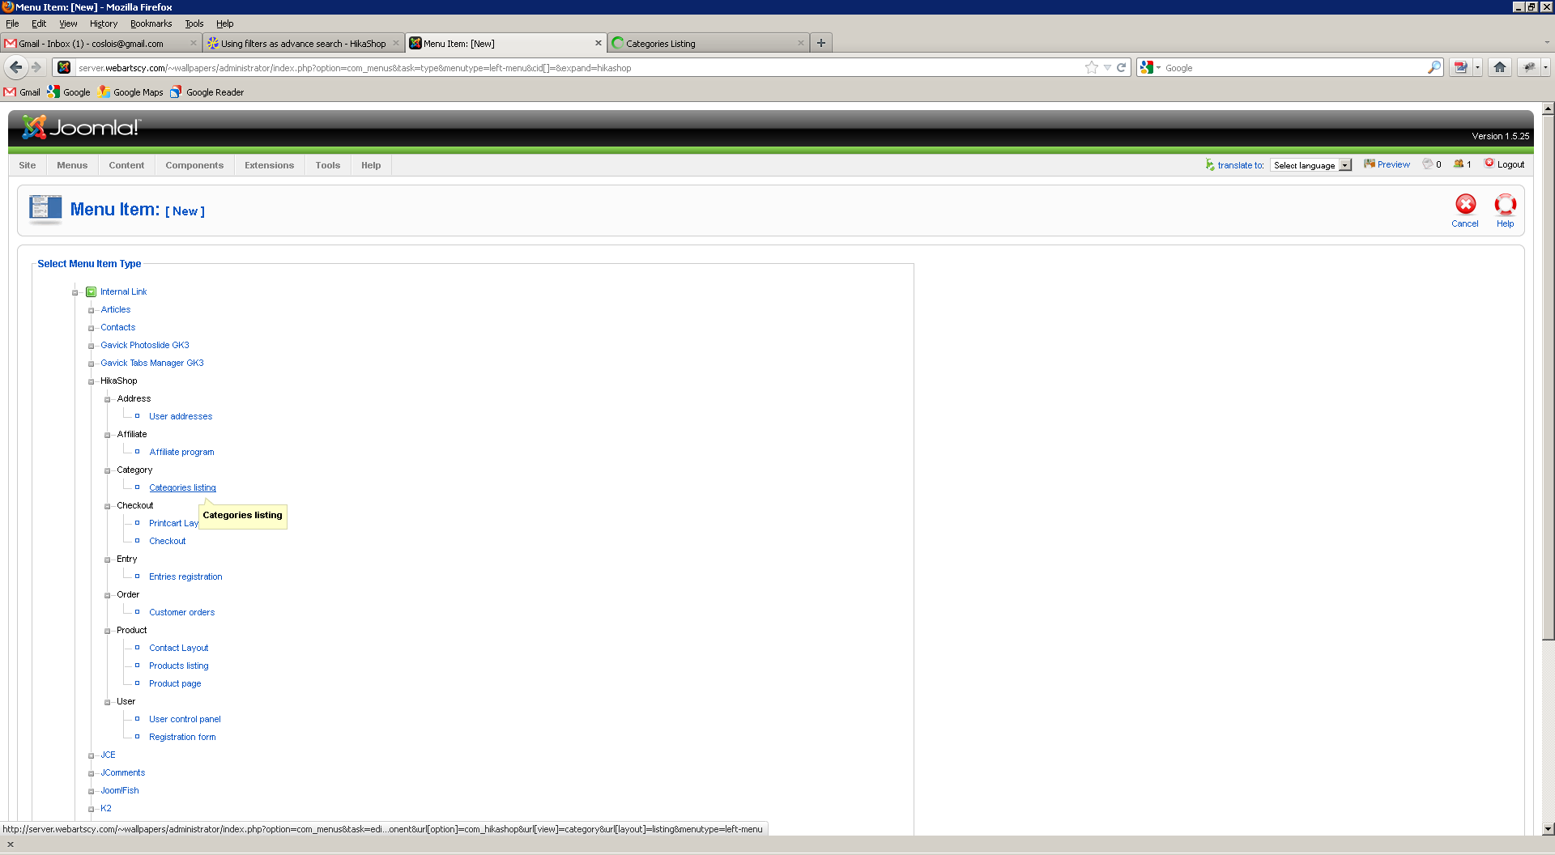

Step2 – Save the menu item so parameters become enabled
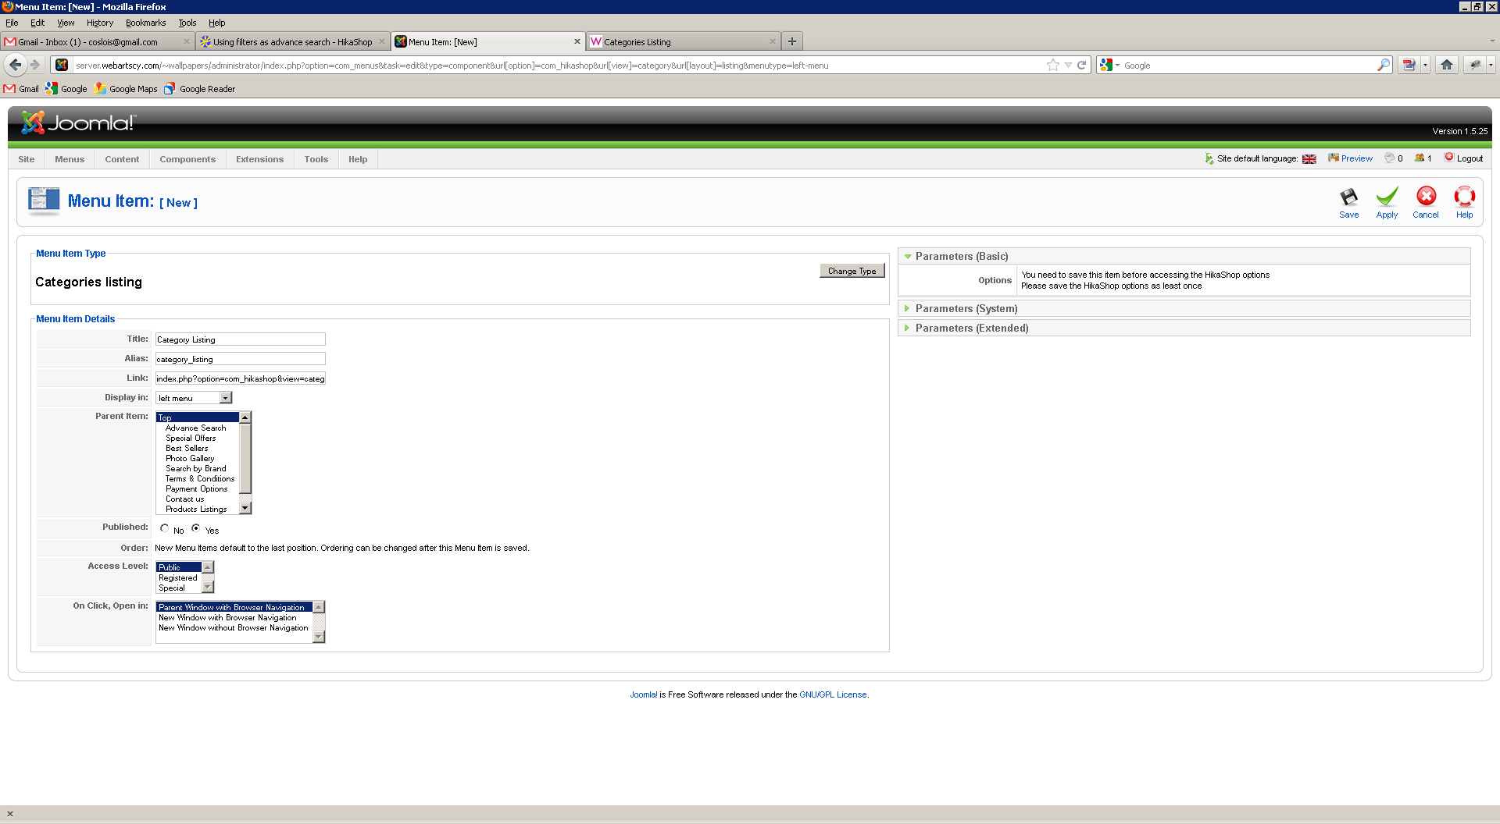

Step 3 – Click on Hikashop Options
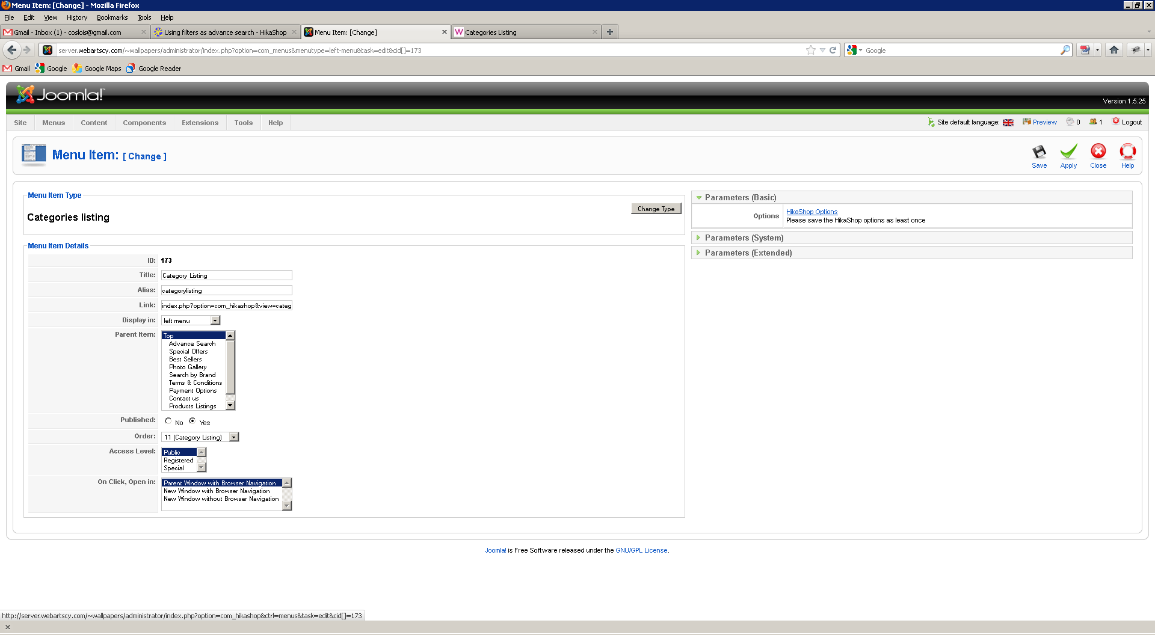

Step 4 - Menu Item Hika Options
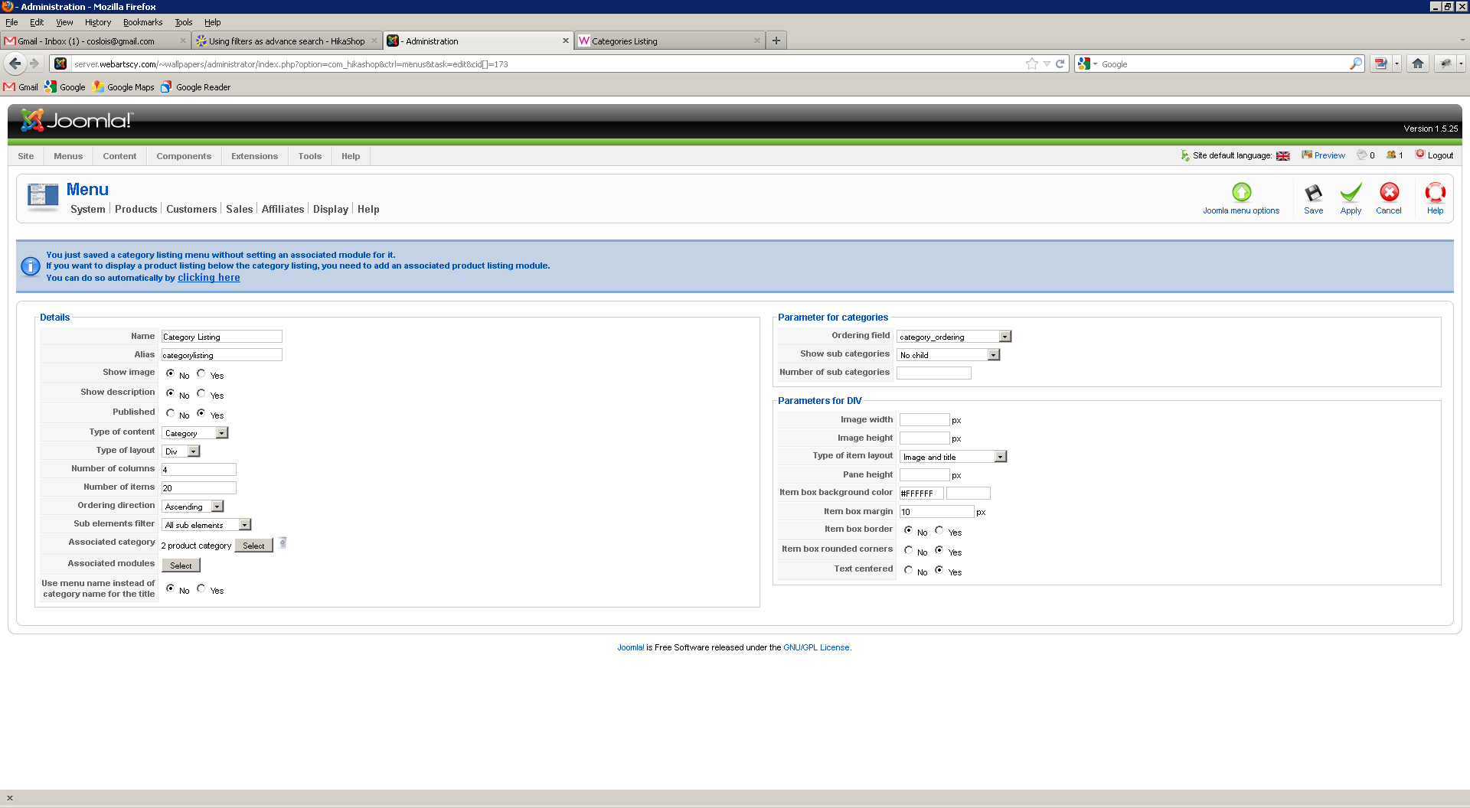
I click on automatic link

Step 5 – Hika Menu item is created (id 173)
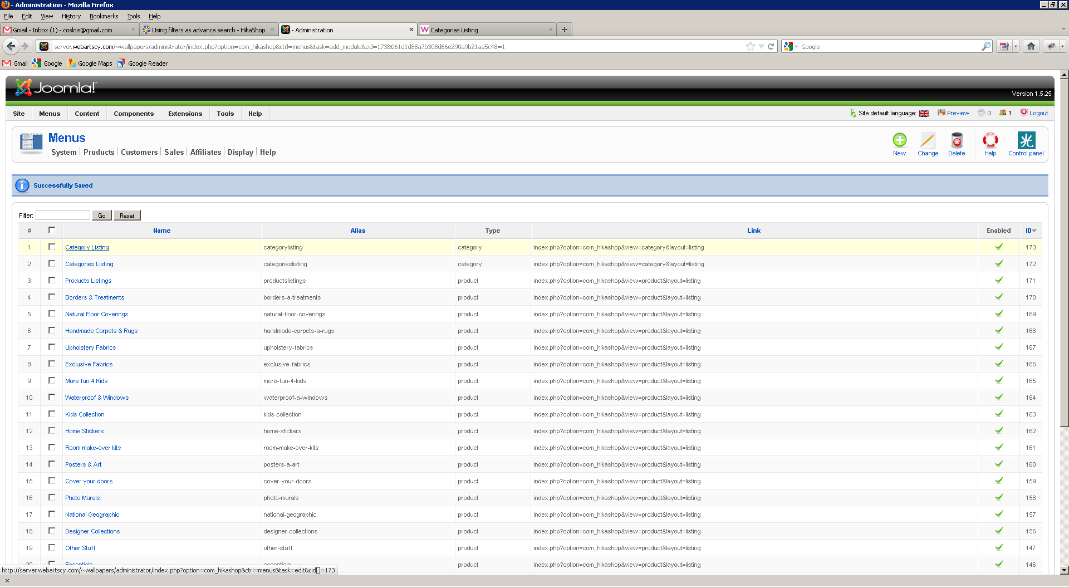

Step 6 – Edit Menu item
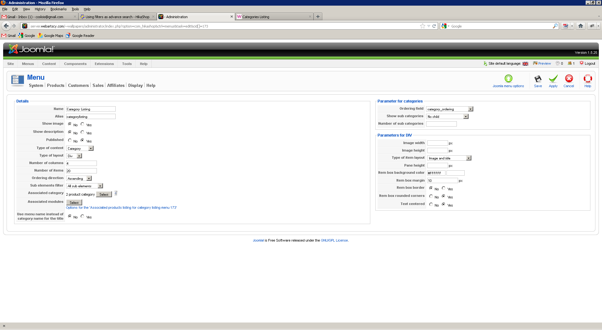
- All sub elements is selected
- Click on Associate Category to select parent category of products to be displayed from filter

Step 7 – Select parent category “Wallpapers”
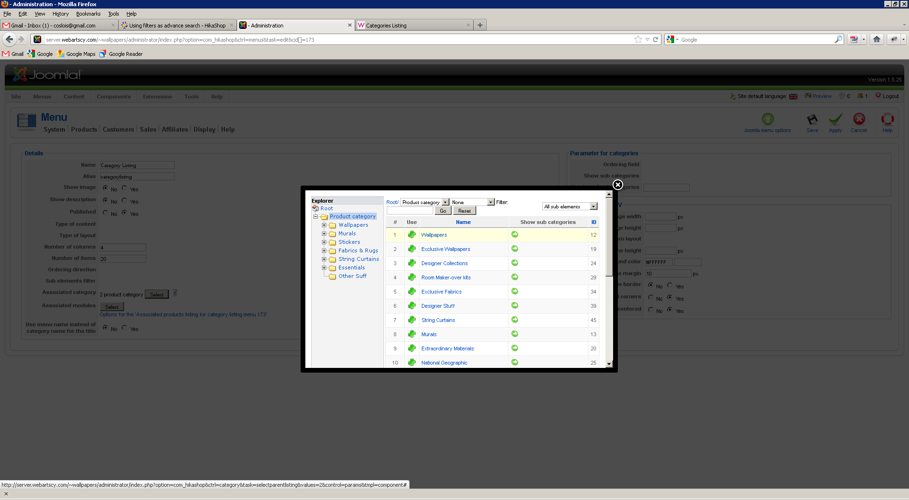
- Save options

Step 9 – Edit Module and use the id from step 5
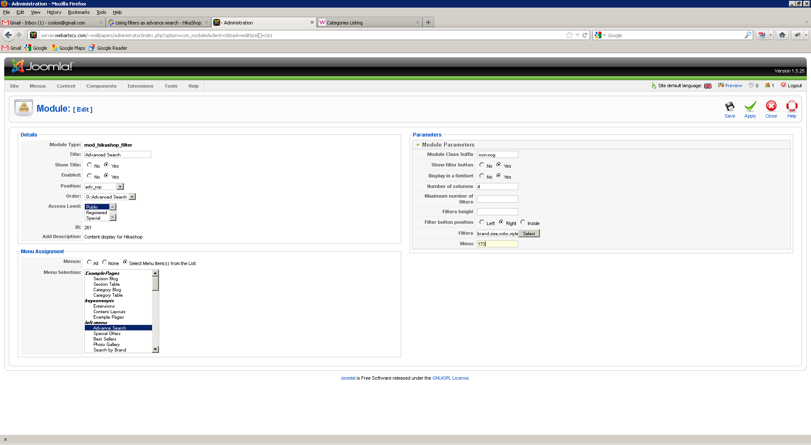

Step 10 – Test the filtering
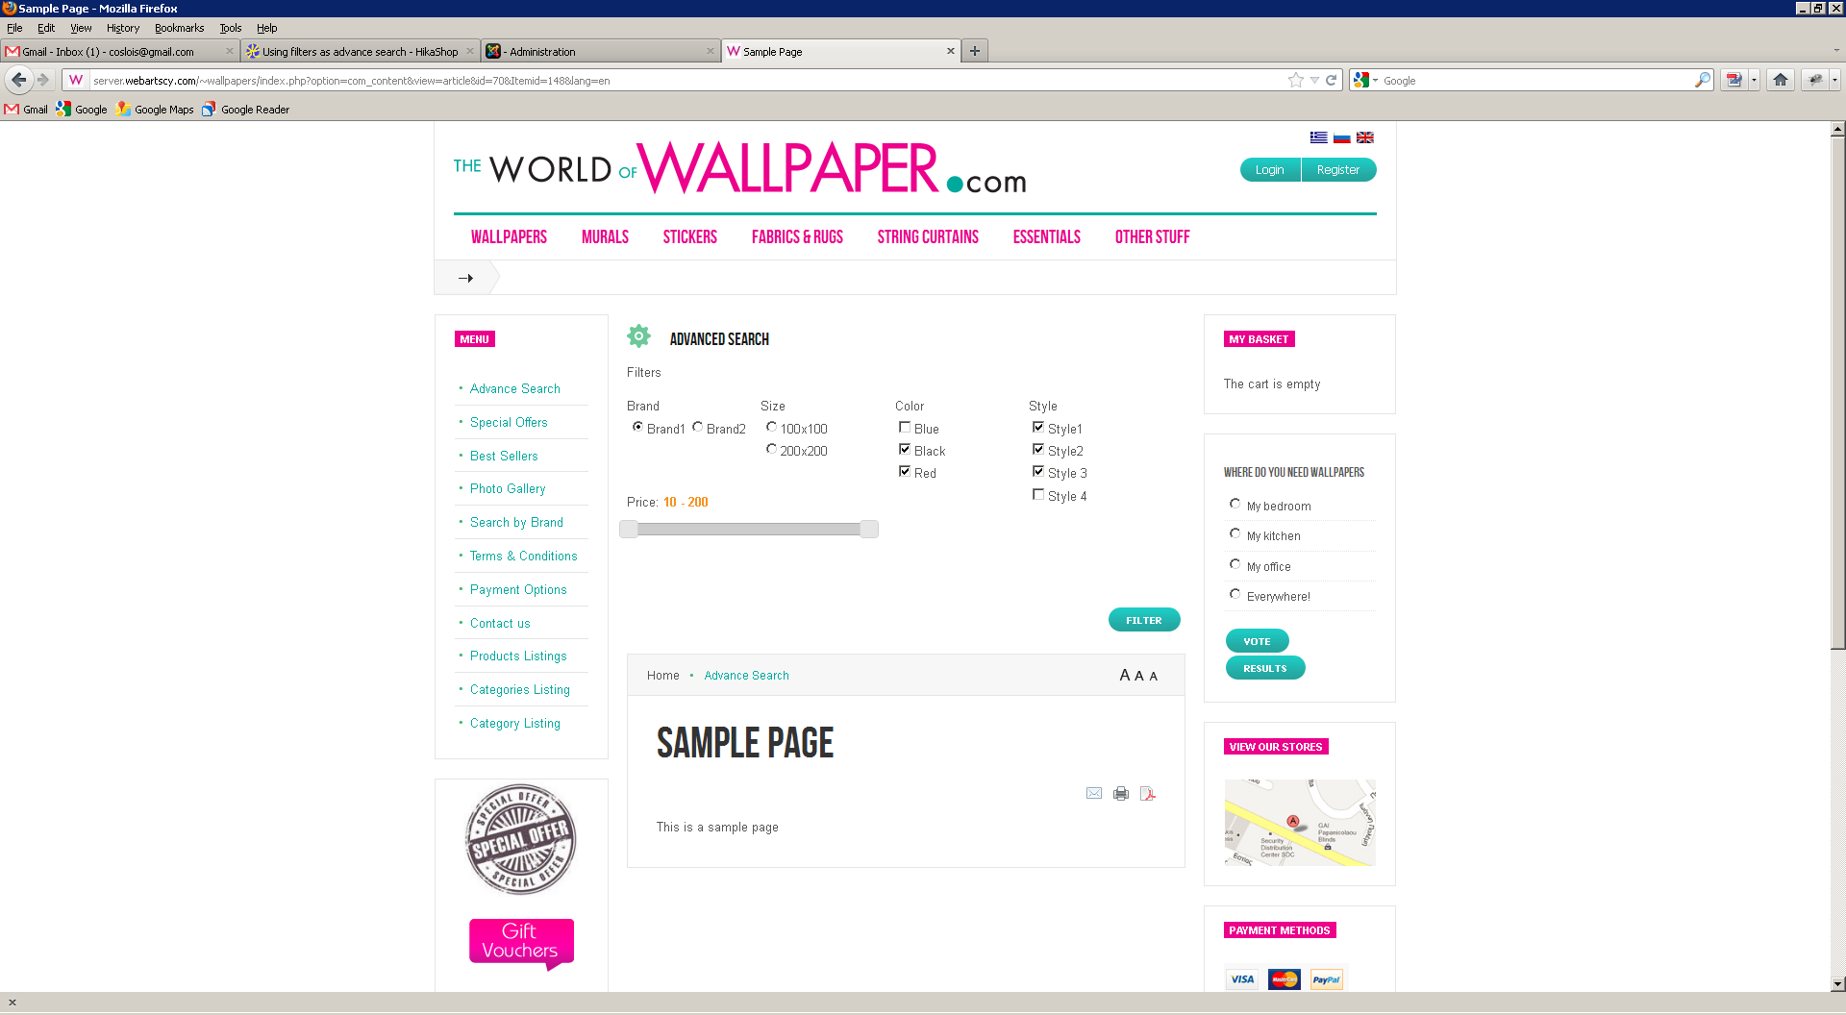

Step 11 – Results are categories and not products as required
