Checkout page – doesn’t display States dropdown

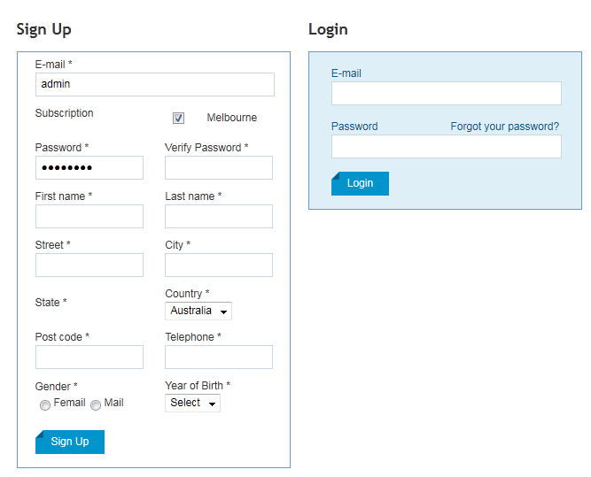

Hikashop Registration Form page – displays States dropdown
