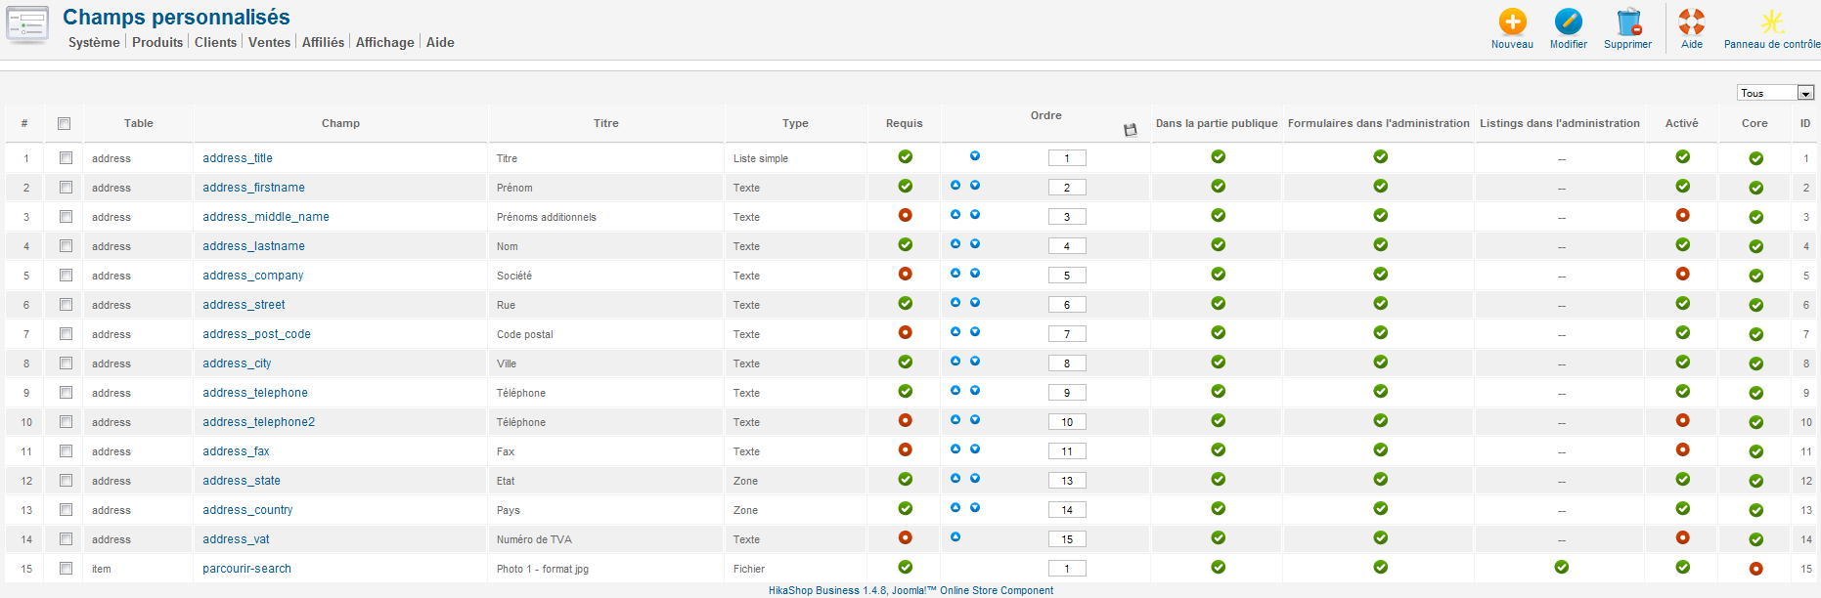

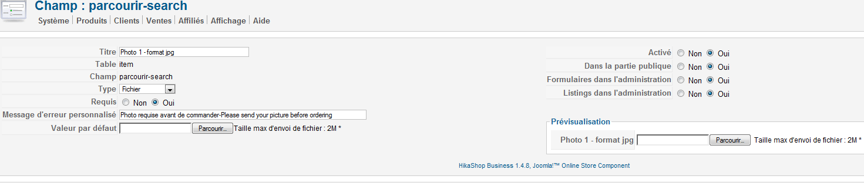

After uploading my picture with the « photo 1 » button and adding to the cart, the cart doesn’t show the product quantity, description and price.
If I unpublish the custom field upload picture, the product informations appears into the cart. Thank you for your explanations. Zelielo

